
Full Electric Pallet Truck

- Operation Manual

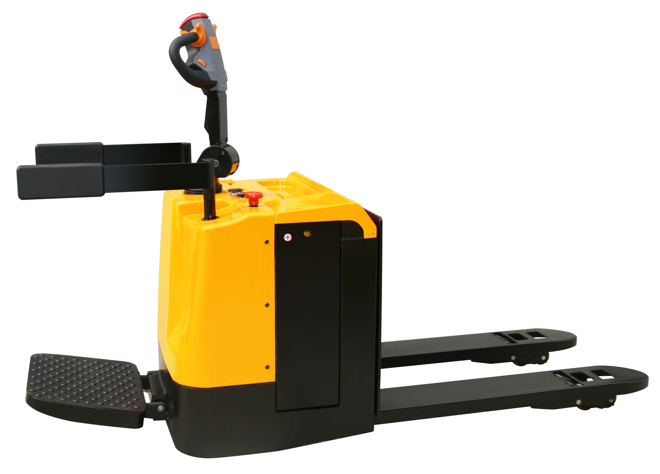
Contents
1. Contour diagram 5
2. Main technical parameters 5
3. Application 7
4. Structure (refer to the structure diagram of the major parts and the schematic diagram ) 7
5. Operation instructions 7
6. Maintenance 9
7. Common faults and trouble shooting 10
8. Use, maintenance and charge of the storage batteries 12
9. Packaging & transportation 14
10. Warning (points for attention) 14
11. Structure diagram of the major parts 14
12. Packing list 15
13. Hydraulic Principle Diagram 16

We hope our products will provide great convenience for you!
Please read the instructions carefully before using the electric pallet truck
This instruction is for reference only. Please subject to the real object if there are any difference between the contents of this instruction and the product.

Warning!

The operator should strictly follow ISO 3691:1980 Safety Specification for Industrial Vehicles and it is prohibited for untrained people to operate the truck.

1. Contour diagram
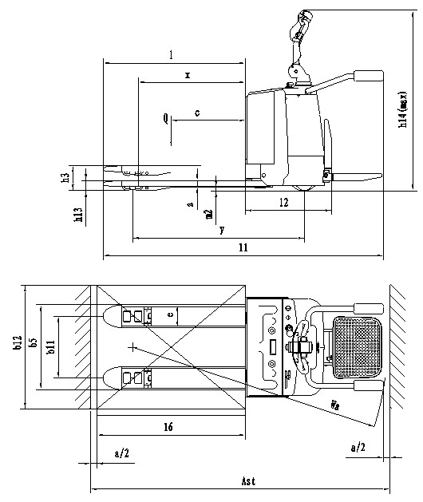

2. Main technical parameters
Specifications | 1.2 | Model
Specifications | 1.3 | Driving model：Electric(Storage battery), diesel, gasoline, fuel gas |  | electric
Specifications | 1.4 | Operating (Manual, Walking, Stand driving, seat driving ,Order picking) |  | Stand driving
Specifications | 1.5 | Rated Capacity | Q(kg) | 2000/2500/3000
Specifications | 1.6 | Load center distance | c(mm) | 600
Specifications | 1.7 | Center of drive axle to fork | x(mm) | 800
Specifications | 1.8 | Wheelbase | Y(mm) | 1310/1360
weight | 2.1 | Service weight(with battery) | kg | 700/870/900
Chasis | 3.1 | Wheels (rubber, high elasticity, pneumatic tyre, polyurethane wheel) |  | POLYURETHANE
Chasis | 3.2 | Wheel dimension, front |  | Φ248×75
Chasis | 3.3 | Wheel dimension, rear |  | Φ80×80
Chasis | 3.4 | Additional wheel |  | Φ115×50
Chasis | 3.5 | Wheel number, front/rear (x = driving wheel) |  | 1X+2/4
Chasis | 3.6 | Thread, front | b₁₀(mm) | 560
Chasis | 3.7 | Thread, rear | b₁₁(mm) | 355/500
Size | 4.1 | Max. lift height | h₃(mm) | 120
Size | 4.2 | Height, Fork lowered | h₁₃(mm) | 85
Size | 4.3 | Overall length | l₁(mm) | 1900
Size | 4.4 | Overall width | b₁(mm) | 754
Size | 4.5 | Fork dimension | S/e/l(mm) | 57*160*1150  /55×185×1150
Size | 4.6 | Fork width | b₅(mm) | 550/685
Size | 4.7 | Ground Clearance | m₂(mm) | 30
Size | 4.8 | Aisle width, with pallet 1000x1200 crosswise | A_{st}(mm) | 2380
Size | 4.9 | Aisle width, with pallet 800x1200 lengthwise | A_{st}(mm) | 2260
Size | 4.10 | Turning radius | W_{a}(mm) | 1720
Performance | 5.1 | Traveling speed, full load/no-load | Km/h | 5/6
Performance | 5.2 | Lifting speed, full load/no-load | m/s | 0.06/0.08 （0.06/0.05）
Performance | 5.3 | Descending speed, full load/no-load n | m/s | 0.05/0.045（0.04/0.08）
Performance | 5.4 | Max. Gradient, load/unload | % | 8/10
Performance | 5.5 | Traveling brake |  | Electromagnetic brake
Motor | 6.1 | Driving motor power | kW | 1.5
Motor | 6.2 | Lifting motor power | kW | 2.0/2.2/2.2
Motor | 6.3 | Battery voltage/rated capacity | V/Ah | 24/（210/240/270)
Motor | 6.4 | Battery weight | Kg | 210/230/260
Motor | 6.5 | Battery dimension（L*W*H） | mm | 650*245*520/790*202*630
 | 8.4 | Noise level at operator’s ear, according to DIN12053 | dB(A) | 70

3. Application
QBA electric pallet truck adopts storage batteries as the power supply and the DC motor as the driver, traveling by gear transmission. The up-and-down movements of the oil cylinders motivated by the DC motor and the hydraulic transmission system lift the forks. As the traveling and lifting of the truck are electrically driven, it possesses the characteristics of energy saving, high efficiency, stable operation, easy operation, safe and reliable, low noise and no pollution, etc.

Operating environment:
a. the altitude should be no more than 1200 meters
b. the ambient temperature should be no higher than +40℃ and no lower than -25℃
c. the relative humidity should not exceed 50% if the ambient temperature reaches +40℃
d. travel on hard and flat ground
e. do not use the truck in a flammable, explosive or corrosive environment with acid and alkali.

4. Structure (refer to the structure diagram of the major parts and the schematic diagram )
This truck is structured by electric drive wheel, steering assembly, front frame, back frame, lifting oil cylinder, hydraulic station, electric control system, connecting rod wheel supporter and balance wheel, etc.

5. Operation instructions
The truck adopts storage batteries as the power supply for goods handling and stacking and a AC motor as the power source to drive the truck and lift goods. Using and operating correctly will bring great convenience for you, or it will damage the trucks, goods or yourself.
5.1 before operation
5.1.1 Please check if the truck is in normal condition before using like: Is there any oil leakage in the hydraulic pipes? Are the supporting wheels able to operate normally? Is there any block? The trucks with problems are prohibited for operation.
5.1.2 Please check does the battery work as Fig.1: Check if there is any electric power in the batteries with the method indicated in Fig.I. Pull the general power switch out to turn on the general power supply, unlock the electric lock on the handle, check the electric energy meter on the instrument panel of the truck. If the zero end grid is bright, it indicates there is no electric power in the batteries and charging should be conducted at once. It is prohibited to operate the truck without electric power as that will greatly reduce the service life of the batteries and even damage the batteries.
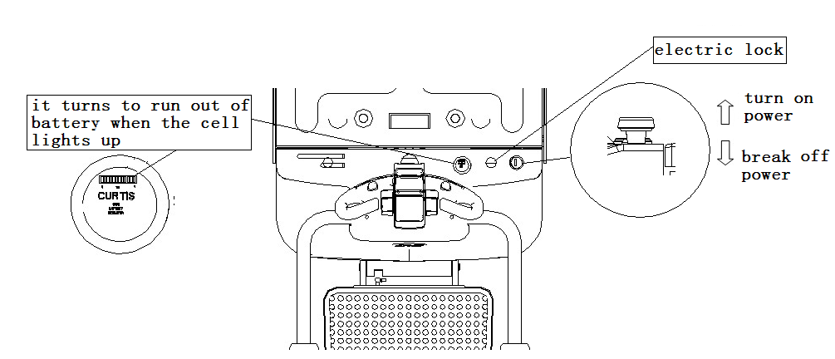
5.1.3 As Fig.2 shows, check if the truck brake is normal; check if the movements of lifting, dropping, forward and backward traveling are normal; check if Check if the emergency reverse action of the truck is normal.
Move the control handle to division A or division C as indicated in Fig.2 and press the rise/lowering button on the control handle to check if the lifting and lowering of the fork is normal.
Move the control handle to division B as indicated in Fig.2, slowly start the truck and press the handle to the horizontal position to see if the truck can travel or brake normally.
Move the handle to division B as indicated in Fig.2, and press the emergency reverse switch button on top of the control handle to see if the truck can travel forward.
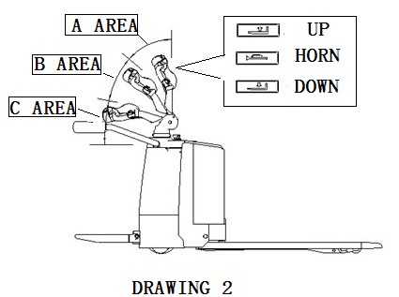
The truck can be used if there are no problems after checking as above, otherwise, please repair it at once. It is prohibited to use trucks with problems.
5.2 In operation
5.2.1 Note: A side-magnetic brake is installed on the shaft end of the drive wheel motor and there is a cam and a fine motion switch installed on the rotary shaft of the rotary arm. Only the rotary arm is at 30°±20° (as indicated in Fig.2), can the truck get power and work. Larger or less than the angle, the stacker will stop for the power will be cut off. In that case, the truck can lift goods. When lifting goods, the truck cannot travel. As indicated in Fig.2, when the control handle is in part A or part C, the truck can only lift or lower but not travel; when the control handle is in part B, the truck can travel, lift as well as lower. The operation position of the handle will not be specially described in the following descriptions, it means. the handle must be in part A or C when the truck lifts or lowers and it must be in part B when the truck is traveling.
5.2.2 Operation of handling
As Fig 1 shows, pull out the switch of general power supply to get power, unlock the electric door lock. Control the travel knob; the truck moves forward when the knob is put to the forward point and it moves back when the knob is put to the back point. While lifting, rotate the knob slowly whether it is with or without load to reach the rated speed smoothly. Move the truck near the goods (the head of the fork is 30cm away from the goods). Press the lowering button, adjust the height of the fork to a proper position, and put the forks slowly under the pallet of the goods as deep as possible. Then press the lifting button until the fork is no less than 30cm away from the ground. Move the truck to the designated place and press the lowering button after the truck stops. After the fork is completely away from the pallet, drive the truck away from the pallet. The handling operation is finished
5.2.3 Adjustment of the brake clearance
①Hollow screw ②Fitting screw ③spring ④Armature
⑤Motor shaft ⑥Spline housing ⑦Friction plate
⑧Electromagnetic coil
⑨Mounting cover plate
⑩Mounting screw
The brake structure is indicated as the Fig on the right. After being used for some time, the performance of the brake may decline with the wear of the brake plate, or the brake can’t be released for the block of the brake plate. It is necessary to adjust brake clearance at this time. As the FIF shows, in the condition of braking, check the gap between the brake block and the friction plate with a feeler. If the gap is more than 0.5mm, the clearance should be adjusted. Before adjustment, clear the dirt and dust on the friction plate. When adjusting, loosen the fixed screw 2, adjust the length of set screw 1, then fasten the retention screws, after adjustment, the clearance between the brake block and electromagnet should be fixed from 0.2~0.3mm. It has to be noted that even adjustment for three retention screws can make even clearance gap between the brake block and electromagnet after adjustment. After the adjustment, turn on the brake with 24v DC power. Then the brake will make clear sound.
- Be alert to obstacles when the truck travels and slow down at turns.
- Switch off the power immediately to cut off the power supply when the truck is out of control
- There is a quick-move switch at the top of the handle assembly, The truck will advance quickly in a reverse direction when it is moving backward after pressing the switch in case of emergency

6. Maintenance
Note: Do not repair the truck without professional training
6.1 It depends on the efficient maintenance that whether the truck can operate perfect. When maintenance is ignored, the truck may pose a threat to human lives and cause property damage. Routine inspection should be conducted, when the truck is in operation, to eliminate abnormal conditions. Never use a truck with trouble to ensure safety and to prolong the service life of the truck.
6.2 Maintenance: The maintenance of the truck is divided into three levels, i.e. routine maintenance, level I maintenance and level II maintenance.
Routine maintenance: Daily maintenance is to clean the surface of the truck body and the surface of the storage battery and to examine the firmness of the power supply cable.
Level I maintenance: Level I maintenance should be performed once every week. Besides what should be done in daily maintenance, the operation situation of all the parts should be carefully inspected to see whether the operation is normal; whether there is any loose of the fasteners; is there any oil leakage at the hydraulic connection; is there any abnormal wearing and tearing in the mechanical parts; is there any abnormal temperature rise or sparks in the electric part, etc. If there is any abnormal situation, adjustment or trouble-shooting should be performed promptly.
Level II maintenance should be carried out as planned. Overall inspection should be performed for the truck according to the following requirements.
a. Maintenance for mechanical system: Once half a year. The major content is to add lubricant to the transmission gears and bearings of the drive wheel and the rotary joints, and examine the firmness of the fixing fittings, the flexibility of the wheels, as well as whether the forks can be lifted and lowered normally. Clean the dirt and dust on the friction plate of electromagnetic arrester and adjust the clearance to the proper distance. The operation noise of the truck should be no more than 70dB after maintenance.
b. Maintenance for hydraulic system: Once half a year. Examine if the oil cylinder is normal, if there is any leakage externally or internally, if the hydraulic connection and the hose are reliable with no leakage. The hydraulic oil should be kept clean and generally it should be replaced every 12 months. ISO oil product standard is adopted for the hydraulic oil. When the ambient temperature is –5~ 40℃, HL-N46 or HL-N68 should be used; when the ambient temperature is –35~ –5℃, HV-N46 or HV-N68 should be used. The replaced waste oil should be treated according to the local rules and regulations.
c. Maintenance for electric equipment: Once every three months. First examine whether the specific gravity of the electrolytic solution of the storage battery [specific gravity at 1.24 (at 25℃) in tropical areas and 1.26 (at 25℃) in other areas] fits and the terminals are clean. Otherwise, the specific gravity of the electrolytic solution should be adjusted as required and the terminals should be cleaned and painted with Vaseline and tightened. Examine if the connections of the electrical devices are reliable, the switches are normal and the insulation is ok (The insulation resistance between the electrical devices and the truck body should be above 0.5MΩ). Clean the dirt, dust, and carbon fouling of motor. Meanwhile check the wearing condition of the electric brush and replace it if necessary.

7. Common faults and trouble shooting

No. | Faults | Cause | Shooting
1 | The truck can’t be started. (The contacts do not work.) | ① The fuse of the control circuit is burn out. | Replace
1 | The truck can’t be started. (The contacts do not work.) | ② The power switch contact is bad or damaged. | Repair or replace
1 | The truck can’t be started. (The contacts do not work.) | ③ The fuse of the major circuit is broken. | Replace
1 | The truck can’t be started. (The contacts do not work.) | ④ The contact of the electric lock switch is bad or broken. | Repair or replace
1 | The truck can’t be started. (The contacts do not work.) | ⑤ The connection of the storage batteries is loose or has fallen off. | Tighten
1 | The truck cannot be started (The contacts work.) | ① The side-magnetic brake of the drive wheel does not suck and the truck is in a braked condition. | Repair or replace
1 | The truck cannot be started (The contacts work.) | ① The walking motor carbon brush is worn or bad contact between the steering device and the carbon-brush. | Repair or replace
1 | The truck cannot be started (The contacts work.) | ② The magnet-exciting coil of the stepper motor is broken or bad contact at the wire end. | Repair or replace
1 | The truck cannot be started (The contacts work.) | ④ Bad contact. | Repair or replace
1 | The truck cannot be started (The contacts work.) | ⑤ There is a trouble at the MOSFET tube type circuit board. | Repair or replace
2 | The truck can only move forward (or backward) | ① Bad or broken contact. | Repair or replace
2 | The truck can only move forward (or backward) | ② There is a trouble in the circuit board. | Repair or replace
3 | The truck can not stop while traveling | Broken contact. The moving contact cannot be reset. | Cut off the power at once and replace the contact
4 | The brake does not work | ① The erection bolt of the fine motion switch looses or is damaged. | Adjust or tighten the bolt or replace the fine motion switch.
4 | The brake does not work | ② The connecting wire of the side-magnet brake is loose or the side-magnetic brake is damaged | Tighten the bolt or repair the side-magnet brake.
4 | The brake does not work | ③ The moving plates of the side-magnetic brake is loose or damaged. | Replace the braking plates.
5 | The steering has got stuck | ① The bearing of the steering device is damaged. | Replace the bearing
5 | The steering has got stuck | ② The bearing of the steering device lacks lubricant or there is too much dust | Clean the bearing
6 | Difficult steering of the drive wheel, noise and the motor is overloaded. | ① The gear or bearing has got stuck because of foreign matters. | Clean or replace the bearing
6 |  | ② There is clearance in the bearing installed or the fixing ring has come off. | Reinstall the ring.  Adjust the clearance.
6 |  | ③ The front wheel bearing is damaged. | Replace the bearing
7 | The forks cannot be lifted. | ① Overload | Reduce the load
7 | The forks cannot be lifted. | ② The pressure of the overflow valve is too low. | Adjust the pressure higher
7 | The forks cannot be lifted. | ③ Internal abnormal leakage in the lifting oil cylinder. | Replace the seals
7 | The forks cannot be lifted. | ④ Insufficient hydraulic oil | Add appropriate quantity of filtered hydraulic oil
7 | The forks cannot be lifted. | ⑤ Insufficient voltage of the storage battery | Charge the battery
7 | The forks cannot be lifted. | ⑥ The operation handle is not horizontal or vertical, the motor of oil pump has not been turned on. | Improper operation
7 | The forks cannot be lifted. | ⑦ Damaged oil pump motor | Repair or replace
7 | The forks cannot be lifted. | ⑧ Damaged oil pump | Repair or replace
7 | The forks cannot be lifted. | ⑨ Damaged lifting button | Repair or replace
7 | The forks cannot be lifted. | ⑩ Electric lock is not unlocked or is damaged. | Repair or replace
7 | The forks cannot be lifted. | ⑾ Seriously insufficient voltage in the cell. | Recharge
8 | The forks cannot be lowered after rising | The electromagnetic valve is out of control | Shoot the trouble
9 | Reduced voltage of the storage battery(after charged) | ① Individual battery is damaged. | Repair or replace
9 | Reduced voltage of the storage battery(after charged) | ② Low level of the electrolytic solution | Add electrolytic solution
9 | Reduced voltage of the storage battery(after charged) | ③Foreign matters in the electrolytic solution | Replace electrolytic solution

8.Use, maintenance and charge of the storage batteries
8.1 Initial charge
Note: The charging environment requires good ventilation and there should be no open flame, otherwise explosion may occur.

8.1.1 Initial charge should be conducted for batteries that have never been used. Before the initial charge, the surface of the batteries should be cleaned and the batteries should be examined for damage. The bolts should be tightened to ensure reliable connection.
8.1.2 Pull out the sealing cover and replace it with the open cover type liquid hole plug and open the cover.
8.1.3 When the charging equipment is able to operate normally, pour the sulfuric acid electrolytic solution with a density of 1.260±0.005 (25℃) and a temperature of lower than 30℃ into the batteries. The liquid surface should be 15-25mm higher than the protective board. In order to reduce the temperature rise caused by chemical reaction of the electrolytic solution and let the electrolytic solution fully penetrates into the pores of the polar plates and the baffles, the batteries should be placed still for 3-4 hours, not exceeding 8 hours. The initial charging can only be conducted when the temperature of the solution reduces to below 35℃. (When necessary, the batteries can be put into cold water for temperature reduction). After the still placement, if the surface of the solution reduces, electrolytic solution should be added.
8.1.4 The sulfuric acid electrolytic solution is prepared with battery sulfuric acid complying with the state standard GB4554-84 and distilled water. Never use industrial sulfuric acid and running water. The standard temperature （25℃）and density of the electrolytic solution can be converted as follows:
D25 = Dt+ 0.0007 (t-25)
Where: D25: the density of the electrolytic solution at 25℃
Dt: the actual density of the electrolytic solution at a temperature of t ℃.
t: temperature of the electrolytic solution when testing the density.
8.1.5 Sweep the electrolytic solution on the surface of the batteries and connect the positive and the negative poles of the battery group respectively with the positive and the negative ends of the DC power supply (charger). Turn on the power supply. First charge with 18A (the first stage current,); when the voltage reaches 28.8V (12 ×2.4V = 28.8V), change to the second stage current 9A and continue to charge. The temperature of electrolytic solution during the process of charging must not exceed 45℃ and when it is close to 45℃, the charging current should be reduced by 50% or the charging should stop temporarily. Wait till the temperature reduces to 35℃ to continue the charging. The charging time, however, should be properly prolonged.
8.1.6 Fully charged basis: When the voltage during the second stage charging reaches 31.2V (12 ×2.6V = 31.2V), the variation of the voltage is no greater than 0.005 (V); the density of the electrolytic solution reaches 1.080 ±0.005 (25℃), no obvious variation in 2 hours and there are fine air bubbles appear violently, it can be deemed that the batteries are fully charged. The charged power capacity is 4-5 times of the rated capacity and the charging time is about 70 hours.
8.1.7 In order to accurately control the sulfuric acid content of the electrolytic solution, the electrolytic solution density of the batteries should be examined during the last period of charging. If there is inconsistence, adjust with distilled water or sulfuric acid with a density of 1.40. The electrolytic solution density and the liquid surface should be adjusted to the stipulated value within two hours in the charging state.
8.1.8 After the initial charging is completed, the surface of the batteries should be cleaned. Close the cover of the open cover type liquid hole plug and then the batteries can be used.
8.2 Use and maintenance
8.2.1 In order to guarantee the service life of the batteries, the batteries in use should be fully charged. Insufficiently charged batteries must not be used. During the process of use, close attention should be paid to the discharge extent. Over discharge is prohibited---the voltage reduces to 1.7V per battery (when the total voltage reduces to 1.7V×12 = 20.4V ). When the density of the electrolytic solution reduces to 1.17, discharging should be stopped and charging should be conducted at once. The batteries should not be placed idle for a long period of time. The supplementary charging frequently conducted during the process of use is called common charge.
8.2.2 Common charge: The first stage current of common charge is 26A and that of the second stage is 13A. The charging method is the same as that of initial charge. The charged volume is 130-140 % of the discharged volume and the charging time is about 15 hours.
8.2.3 The batteries in normal use should avoid over-charge, but over-charge must be properly conducted for the batteries in following situations, i.e. equalizing charge.
  - The “lag-behind” batteries--- batteries with a voltage lower than that of the other batteries in the discharging process and the batteries having been repaired for failure. (When equalizing charge is conducted, the positive and negative poles of the “lag-behind” battery should be respectively connected with the positive and negative ends of the charger, the DC power supply, and the charge should be conducted independently.).
  - Equalizing charge should be conducted for the batteries in normal use every 2-3 months.
  - Equalizing charge should be conducted for the batteries that have not been used for a long period of time before use.
8.2.4 Equalizing charge
- Charge with a 4A current
- When the charge voltage reaches 31.2V (12 ×2.6V = 31.2V) and air bubbles occur in the electrolytic solution, the current should be reduced by 50% (2A) and continue to charge.
- When the batteries are in the state of fully charged, stop for 0.5 hour and charge again with a 1A current for one more hour.
- Stop for another 0.5 hour and charge with a 1A current for another one hour.
- Repeat according to item d till air bubbles occur violently in the batteries once the charger is switched on.
8.3 Storage
8.3.1 Batteries should be stored in a clean, dry and well ventilated warehouse with a temperature of 5-40℃. The valid shelf life is 2 years. The batteries should be kept according to the following requirements during storage:
- No direct sunshine on the batteries and at least 2m away from heat source.
- Avoid contacting with any harmful substances. No metallic matters are allowed to drop into the batteries.
- The batteries should not be placed upright down and should not be impacted mechanically or heavily compressed.
- The batteries must not be stored with electrolytic solution. When it is required in special situation that the batteries must be stored with electrolytic solution, the batteries should be fully charged and the density and the liquid surface of the electrolytic solution should be adjusted to the stipulated values. When the storage period comes to one month, the batteries should be complementarily charged with the common charge method.

9. Packaging & transportation
The truck is packed with a tray. During transportation, turnover and upside-down are not allowed. Collision is not allowed when lifting and loading onto the truck. Do not damage the outward surface of the truck when opening the package

10. Warning (points for attention)
10.1 Read the manual carefully before operation and know well the performances of the truck.
10.2 It is strictly forbidden to press the lift or lower buttons while the truck is walking and frequently switching the two buttons, which might damage the truck and the goods.
10.3 Do not shake the lever rapidly or with high frequency.
  - It is not allowed to rapidly put heavy goods onto the forks.
  - The truck should not be overloaded. When overloaded, the truck will not be able to operate normally.
  - The center of gravity of the goods should be placed between the two forks, otherwise, the forks will be damaged and the goods will fall down in the process of operation.
  - Loose and unstable goods are not allowed to load onto the truck.
  - Do not put the goods on the forks for a long period of time.
  - Turning rapidly on narrow road is strictly forbidden. In order to ensure the safety of the people and goods, the truck should turn slowly in this situation.
10.10 When the truck is not in use, the forks should be lowered to the lowest position.
10.11 Never put any part of human body under heavy goods and forks.
10.12 The truck is applicable for use on plane ground and should never be parked on slope for a long period of time.
  - Over-load or over-slope operation is strictly forbidden. Otherwise the wheel will slip, damaging the wheel and the motor. The safety of people and goods will be affected as well.
10.14 Repairing on one’s own before training is forbidden.
  - Operation of the truck under the stipulated voltage 20.4V is strictly forbidden.
  - It is strictly forbidden to directly connect the plug with AC power supply for charge.

11. Structure diagram of the major parts
- “The principle diagram of hydraulic system”
- “The principle diagram of electrical system”

12. Packing list
Packing List of QBA Electric Pallet Truck

Consignee: Ex-work No.:
Contract No.: Ex-work date:
SN | Name | Quantity | Net weight | Dimension  (L×W×H) | Remarks
1 | electric pallet truck | 1 |  |  | A complete set.
2 | Accessory box | 1 |  |  | Technical documents, accessories and spare parts.

Note: 1. The following documents are in the file bag:
①Operation manual of Electric Pallet Stacker 1 volume
②Packing list 1 copy
③Qualification certificate 1 copy

2. Accessories and spare parts
SN | Name | Use position | Type & specification | Quantity | Remarks
1 | Key to electric lock | Unlock the electric lock |  | 2
2 | Charging plug and socket | Matched with the charger |  | 1 set | With no charger for built-in type
3 | Fuse | Electric equipment | 200A | 1
4 | Fuse | Electric equipment | 125A | 1

13. Hydraulic Principle Diagram

